Using the pivot tablemodule from DHIS-2 to analyze data

# Overview:

The DHIS-2 platform has a pivot table module that can be used to analyze DHIS-2 data in tables. This module is also used to create report tables from which iReports are usually produced.The advantage of creating pivot tables directly in DHIS-2, rather than downloading the raw data over the internet and using it in Excel, is that you can get your results much quicker – especially with low bandwidth connections.

The basic pivot table looks like the following:

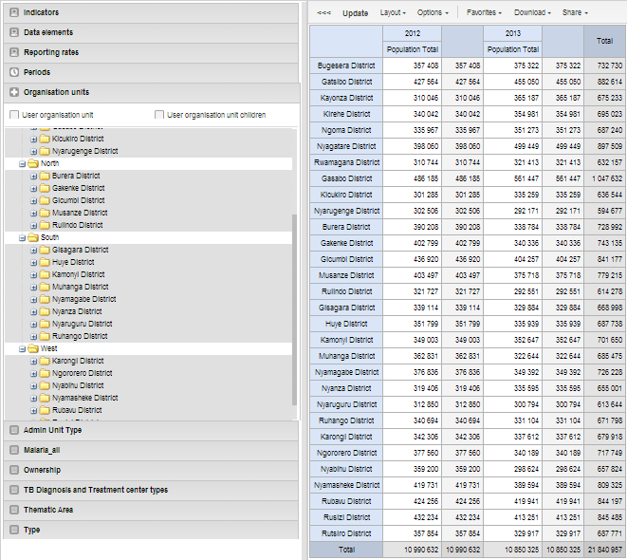

# Step by step guidelines for creating Pivot Tables:

|  |  |
| --- | --- |
| 1. From the Services menu select Pivot Table. 2. When you load the Pivot table module you see the screen at right. This dialog box enables you to select:    1. Indicators to display    2. Data elements to display    3. Reporting rates    4. Organization units    5. A list of organization unit groups and thematic areas by which to group the data |  |
| 1. For a basic pivot table select an indicator. |  |
| 1. If you decide to select a data element you will see the screen at right:    1. You can select a data element group using the combo box.    2. Click on the data element(s) you wish to display and move them across to the “Selected” box by clicking on the right arrow icon. You can pick more than one data element.    3. You can also decide if you want to display totals for the data element selected or details (this adds all category option combinations such as age and sex groups) |  |
| 1. Next select the time periods that you wish to display:    1. **For fixed periods:** such as specific months and years use the combo box to select the period type (yearly, monthly, etc…)    2. Select the periods that you wish to include in your report, and press add selected to move them to the selected periods box.    3. Use the Prev and Next buttons to get time periods from earlier or later years.    4. For relative periods: make sure the selection box at the top is empty and check the box next to the relative periods you wish to display |  |
| 1. Select the organization units that you wish to display or compare 2. If you want to display more than one organization unit, you can press <Ctrl> and then click to select or unselect multiples. |  |
| 1. To see your table, press the Update option on the menu above the graph display window. |  |
| 1. In order to display categories or change the position of periods or indicators you should click on the Layout menu to display the Table Layout dialog box.    1. Drag and drop any of the dimensions into the column or row boxes**.** You can also drag attributes from the column to row boxes to pivot the table.    2. Press Update to display the pivot table with the new settings. |  |
| 1. Manage Favorites: by clicking on the Favorites menu, you can display the screen at right. 2. You can search for favorites by typing part of the name or you can browse the existing favorites by pressing next or previous to go through the list. Click on the name of the favorite to display the pivot table. The buttons on the right of each pivot table title are:    1. **Edit** the details for the pivot table    2. **Update** favorite with the currently displayed data    3. **Share**this favorite with other users. Normally the only pivot tables you see are the ones that you have created.    4. **Delete** this favorite |  |
| 1. If you have created a new pivot table and want to add it as a new favorite, click on the **“add new”** button and the dialog at right will open up. Type in a name for your pivot table and press Create. Please try to use a meaningful name that can also serve as a title for the pivot table. It should accurately describe the subject of the pivot table so that others will understand what is in it. |  |
| 1. Since the pivot tables have now replaced report tables as the source of data for standard reports, there is another dialog that helps you specify the how you want to display the data and what parameters to use when running standard reports.    1. **Data:** check the box as appropriate to show totals, sub-totals or to hide empty rows of data.    2. **Style:** allows you to change font sizes and specify how what character to use to separate digits.    3. **Parameters:** check any of these so that when you run a standard report the system will prompt for the corresponding parameter. |  |
| 1. **Downloading data:** Once you have created your pivot table the way that you want it, you have many options to download it to your computer.    1. **Table layout:** this provides you with data displayed in the same format as you see on the screen. Indicator names and categories are appended together in the headings (e.g. “ANC registrations January 2013”)    2. **Plain data source:** this puts each cell in a different row with different columns for each attribute (indicator, period, organization unit, etc..). This is the best format if you want to use the data for creating a pivot table in Excel afterwards. |  |
| Remember to press Update after any changes to display the new format. Also, if you want to include the changes in your favorite, be sure to overwrite the favorite name. After updating you should see a screen similar to the following: | |
|  | |